**Chapter 20 – Update on My Parents & Siblings**

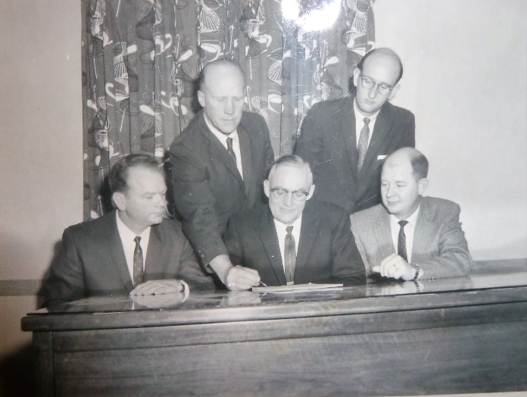**Dad** had been in the High Counsel of the North Davis Stake for quite a few years. He really enjoyed this position. Shortly after, Dad was asked to be **the Bishop of the Sunset 2nd ward** as Bishop Nicholas was being released after being Bishop for eleven years. What a challenge for dad. Dad Chose Carl Grimstad and Dwane Baldwin for his counselors. A few months later, Duane had to move so both he and Carl were released since Carl's work affected his time too much. Clayton Peterson and Brother VanBrocklin are his new counselors. Everyone loved dad and he was a wonderful bishop.

**Mom** is the Primary **Stake Secretary of the North Davis Stake**. She enjoys this very much. (I have written much more about Mom in other chapters)

**Bryce** is on his mission in Uruguay. Mom lets us read his letters and lately they are very wonderful and enlightening. During the first part of his mission he was quite discouraged and homesick. I think this was because most of his companions were just about ready to come home so they just went sightseeing and buying souvenirs and didn't do much missionary work. Now that he's senior companion, things are working out better for him and he's enjoying his mission.

**Hal** is still the same old carefree "live for today, for tomorrow you may die" fellow. He is a fireman here at one of the fire stations in Ogden. He lives with the folks, and is a pretty good kid other than he isn't a bit religious and spends his money as fast as he gets it. He is good to help the down trotten though. He always felt sorry for Uncle Royal and Aunt Maurine, and would go visit them and take them gifts. When he was in the Air Force and stationed on the island of Crate, he was always helping the poor people there - buying groceries for them, especially his house helper as he felt sorry for her and would buy groceries for her to take home to her family.

After Hal returned home after his time in the Air Force, he went to Las Vegas and was a fireman there. Hal tried his luck at gambling and on one occasion, he got into a card game in a back room with profession gamblers. Hal was smart and could usually win most games, but this time he was in over his head. He couldn’t quit as he couldn’t pay what he would have owed and if he didn’t pay, he felt they would take him out in an alley and kill him, so he kept playing (don’t know how you can do that without the money, but he did) In the wee hours of the morning, he finally won enough hands (or games) that he could quit, pay them off and get out of there, and that’s exactly what he did. And he moved back home with our parents as he didn’t trust himself there in Las Vegas any longer. (At least this is the story I remember hearing.)

Hal received his GI Bill, after he was honorably discharged from the Air Force, so he decided to use it and he went to Weber College. Terry was also going there and those two brothers are very smart so, in the classes they took together, they competed with each other for the high in the class. (I think Hal told Ken this and Ken told me.)

Hal called me one day, he was living with our parents and my parents took their other children and went on a vacation to visit Uncle Dean & Aunt Stella in Arkansas. Hal had to work, so didn’t go with them. Ken and I were living in Ogden. Hal said: “Mae, could you come here and wash me so pans as I don’t have a frying pan or any other pan to cook me some eggs in?” I told him he could wash some himself. But he said: “Please, please Mae, please come and wash me some.” I finally gave in and went to Sunset and washed his pans and other dishes. Hal never did dishes while we were growing up. I was the girl and somehow just the girls do the dishes. We had lots of dishes and I sure didn’t think it was fair that my brothers didn’t have to help me. Anyway, Hal and I had a good visit while I was doing his dishes, and I do love the guy.

.

**Terry** is a Junior at Clearfield High School. He's six foot four inches tall and is really thin. A beanpole you might say. When we would invite him to our home and I would fix us meals, I wondered if I would ever fill him up, especially with pancakes. I thought he must have a “hollow” leg. He's a good piano player and is really studious. He likes to read. I wish I was more like him in that respect.

**Georgia** is a Freshman at Sunset Junior High School. She's really getting cute. She's a sweet girl and I'm really thankful for a sister like her. She went up to camp with me this year and really had a great time. She tends Sandy for me sometimes and is really good with her. Sandy just loves her. I'm eleven years older than Georgia, and Georgia is eleven years older than Sandy - give or take a few months. When I was eleven, Grandpa Porter passed away, and when Georgia was eleven, Grandpa Bushnell passed away.

**Kim** is feeling his oats right now and is a worry to our parents. He isn’t as respectful to our parents as he needs to be. I hope he changes and realizes what wonderful parents we have. (He did and is a wonderful man, son, husband, father, brother, friend and a righteous son of God. I am proud of him and love him very much.)